SPLENDID PUGLIA
Sat May 18-Sat May 25, 2024
Private Group with Linda Bell

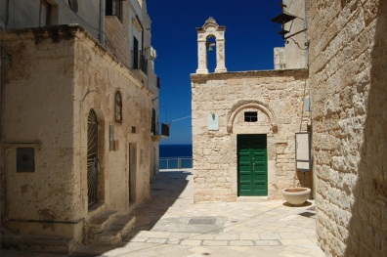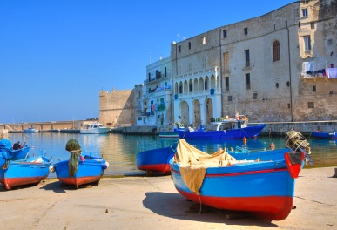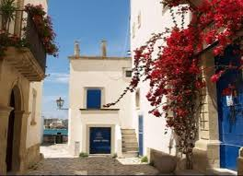
A journey of exploration, warm locals, art and tradition, food and wine, authentic Puglia atmosphere. Benvenuti in Puglia, welcome to the heel of Italy, the country’s least-exploited tourist destination, which has been conquered by just about everyone, from the Byzantine Greeks to the Romans, the Arabs and the Bourbons.
Hundreds of miles of golden beaches with azure water, a breathtaking combination of whitewashed hilltop villages and the Baroque beauty of cities such as Lecce. Plus some of the cheapest, simplest and tastiest food in Italy.
Lecce is one of the most beautiful Baroque city in Italy and it is located near amazing beaches with crystal clear waters on both the Adriatic and Ioanian Seas.
During this trip, in a well -balanced blend of culture and lifestyle, you’ll explore the diverse artistic and architectural styles of Puglia.
Puglia’s architecture is a mish-mash of cultural influences in such a simple way that’s unpretentious, easy, and eminently Salentino.
Puglia has a microclimate that ensures sunny weather for much of the year. Il solleone in summer, the so-called lion sun, and a fertile land allow Puglia to grow intensely flavored olives, fruit and vegetables in abundance. Thus, it produces much of Europe’s pasta, presses most of Italy’s olive oil, catches the bulk of the country’s fish and makes plenty of good, strong wine – enough, in fact, to be the sixth biggest wine making region in the world!
Bread, oil and wine are the central forces in the Puglia diet. It is the place of the so called Cucina Povera (the cuisine of poverty) and it is certainly true that this poor area has made the very best of its local produce. Pasta made without eggs, bread made from the local vegetables, and more make the area a true mecca for the wine and olive oil production. There are no rules; recipes have long been improvised from what is available.
Cucina Povera is probably one of the most delicious, environmental and conscious way of eating based on affordable ingredients or whatever is on hand in the farm and in the kitchen. Inspired by local seasonal ingredients, a mix of cereals, vegetables and legumes this diet has been emulated by many world-wide.
Puglia is the ideal backdrop for a relaxing experience and a rustic-chic holiday to remember.
Discover Puglia’s many small towns and villages, a treasure trove of lifestyle art, architecture, history, design and culture. Simply relax and soak in Puglia’s simple, laidback way of life. Enjoy the landscape, the food, and the warm hospitality of the locals.

Your Itinerary 2024 - SPLENDID PUGLIA
This trip has been designed to immerse in the local culture. Every day you’ll explore a part of the region and discover its incredible beauty: architecture, sacred sites, characteristic historic towns, food and wine, locals. Yet you’ll have plenty of free time to relax and explore on your own and enjoy the unique indigenous lifestyle.
In this itinerary, we have included the very best of Puglia, through places where you can truly get the real feel of the region, staying in lovely places and exploring with expert local guides.
There’s an austere beauty to Puglia. A holiday in Puglia is a great pleasure. It’s a magic puzzle of beauties where you get lost. It is that special beauty that makes it clear that you are absolutely nowhere else. (See full itinerary details on the next page)

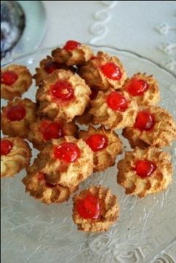
YOUR ITINERARY
DOLCE VITA IN PUGLIA
DAY 1 - ARRIVAL DAY LECCE

- Arrive Brindisi airport and pick up transfer to 4 STAR LUXURY HOTEL- TO BE NAMED
- located in the historic section of old town Lecce.
- Lecce, a beautiful Baroque city is sometimes referred to as the “Florence of the South”.
- Our hotel will be close to restaurants and shops and very easy to stroll around to soak in the splendid Italian culture!
Pre-dinner introduction of the trip with Linda's local hosts and glass of wine.
Welcome dinner in Lecce

DAY 2 - TOUR OF LECCE WITH PASTA CLASS FOLLOWED BY WINE TASTING LUNCH

- Extra activities we can arrange not included in the price: hiking and/or biking with a guide, deep tissue massages, yoga sessions.
- Dinner on your own in Lecce
- Bikes are for rental and we suggest having a guide with them who knows how to tour around the area.

DAY 3 - TOUR OF GALATINA AND GALLIPOLI WITH A SEA-VIEW LUNCH

- After breakfast, excursions to the charming southern towns of Gallipoli and Galatina with lunch
- Explore Gallipoli, the town of fishermen and Mediterranean flair and enjoy lunch savoring the traditional cuisine
- Galatina is an elegant little town of Salento with its magnificent Basilica of Santa Caterina d'Alessandria scattered with Frescoes of the Romanic Gothic Art in Puglia
- Return to the hotel around 5 pm
- Dinner on your own in Lecce.

DAY 4 - BOAT TOUR TO SEE THE SALENTO GROTTOS AND GUIDED TOUR IN OTRANTO
- A tranquil experience will await us as we head to see the sea caves along the Salento peninsula surrounding the charming town of Otranto.
- The town of Otranto is famous for its rocky coast and cliffs and stunning sea views.
- On a clear day one is able to view across the Ionian Sea, which separates Italy from Albania, and see the coastline of Albania.
- We will have a guided tour including lunch in this medieval charming town.
- Return to Lecce and enjoy a pizza dinner with our group second to none!

DAY 5 - WINERY EXPERIENCE AND CHECK IN TO HOTEL IN MONOPOLI

- Check out of hotel in Lecce after breakfast and head toward the coastal town of Monopoli.
We will call this day "photo walks" capturing the beauty of the white washed stone villages of Puglia with tiny houses, and bloomed balconies.
Lunch will feature the food specialties of central Puglia.
- We will visit TO BE NAMED Winery and sample the unique wines native to Puglia.
- We will check into a 4 star hotel TO BE NAMED in the historic section. close to shopping and restaurants in this beautiful fishing town with its characteristic charm.
- Dinner at leisure.
DAY 6 - TOWNS OF THE ITRIA VALLEY INCLUDING ALBERBELLO/ CHEESE MAKING DEMONSTRATION
- Excursions to the fairytale town of Alberobello where you will see the famous Trulli houses, which earned this town a world UNESCO heritage site.
Lunch will feature the special foods of the Itria Valley simple cuisine.
- In addition, we will be able to see how the amazing cheeses of the area and of course sample many!
Return to Monopoli.
Dinner at leisure.

DAY 7 - DAY TRIP TO MATERA WITH GUIDED TOUR AND LUNCH

- The oldest city in Italy — and the oldest in Europe, too — Matera is a UNESCO World Heritage city that was also the European Capital of Culture in 2019. This is because of the unbelievable cave dwellings that were inhabited by people up until the 1950s.
- First inhabited by Benedictine and Basilian monks, you’ll see individual cells, chapels, and even some churches - many adorned with Byzantine decorations and frescoes. This is a not to be missed opportunity when touring in Puglia.
- Dinner on own, may be back a bit later today.
DAY 8 - DEPARTURE DAY

- Arrivederci Puglia!
- Private transfers to Brindisi airport or Bari airport.

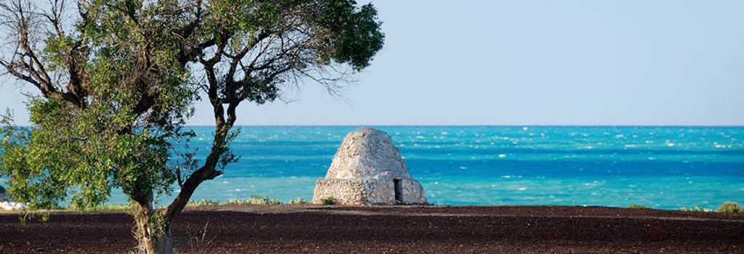

INCLUSIONS

4 nights in Lecce **** Hotel
3 nights in Monopoli ****Hotel
Wine and tips included in all meals
All European style breakfasts at hotels
1 dinner in Lecce (check-in day)
1 pizza dinner in Lecce
All lunches
Group transportation from arrival to departure
Bilingual hosts + private guides
1 cooking class
1 winery experience with tastings
1 cheese experience with tasting
Excursions as per program featuring lovely restaurants for lunch

OPTIONAL EXTRAS

We can arrange for you anything you would like during your leisure time – yoga, biking, hiking, horseback riding, sailing, massages…prices for these are not included but we can make all arrangements for your pleasure.

IMPORTANT INFO:

We highly recommend travel insurance to assist you in the event of medical emergency, lost baggage, cancelled trip or any other trip related issue.

We reserve the right to make modifications and to make substitutions to the itinerary as necessary to improve the trip quality or to accommodate the comfort, convenience and well-being of the travelers. In this event we will always substitute an equal or better option.

Dates:
May 11-25th 2024
May 18th-25th 2024

Tips:
Housekeeping at hotels and driver/tour guide is NOT included and will be left to your discretion)

